WEEK : 2
AIM :
To implement and use lambda expressions in Java by creating methods that return lambda expressions to check whether a given number is odd or even, prime or composite, and palindrome or not, using a functional interface.
ALGORITHM :
- Create a functional interface PerformOperation with a single abstract method
boolean check(int a).
- Create a class MyMath that contains:
- A method checker() to apply a given lambda operation on a number.
- A method isOdd() that returns a lambda expression to check if a number is odd.
- A method isPrime() that returns a lambda expression to check if a number is prime.
- A method isPalindrome() that returns a lambda expression to check if a number is palindrome.
- In the main() method:
- Read the number of test cases.
- For each test case, read the operation type and the number.
- Based on the operation type:
  - Call isOdd(), isPrime(), or isPalindrome() to obtain the corresponding lambda expression.
  - Pass the lambda expression and number to the checker() method.
- Print the appropriate result.

PROGRAM :
public static PerformOperation isOdd() {
return a -> a % 2 != 0;
}

public static PerformOperation isPrime() {
return a -> {
if (a <= 1) return false;
for (int i = 2; i <= Math.sqrt(a); i++) {
if (a % i == 0) return false;
}
return true;
};
}

public static PerformOperation isPalindrome() {
return a -> {
int temp = a, rev = 0;
while (temp > 0) {
rev = rev * 10 + temp % 10;
temp /= 10;
}
return rev == a;
};
}
}

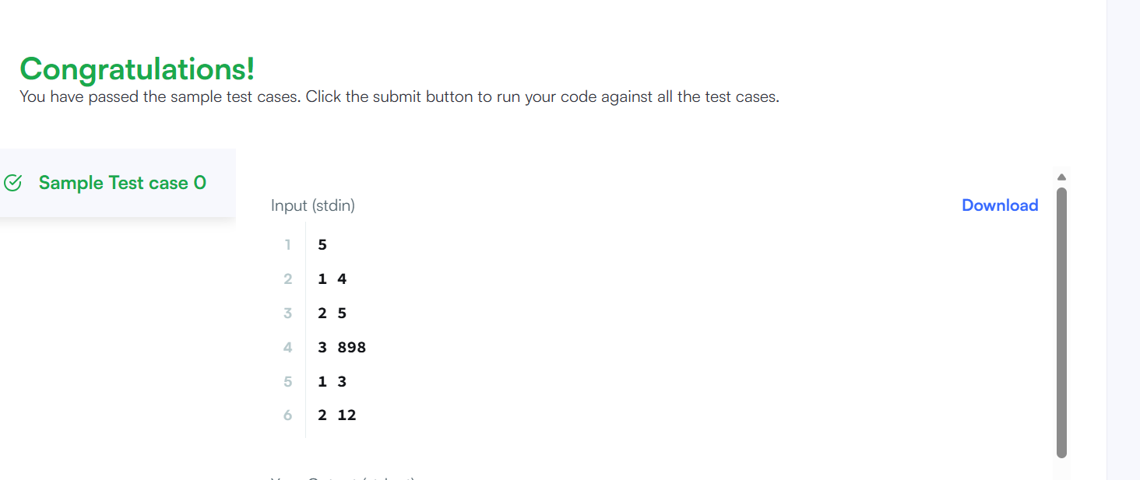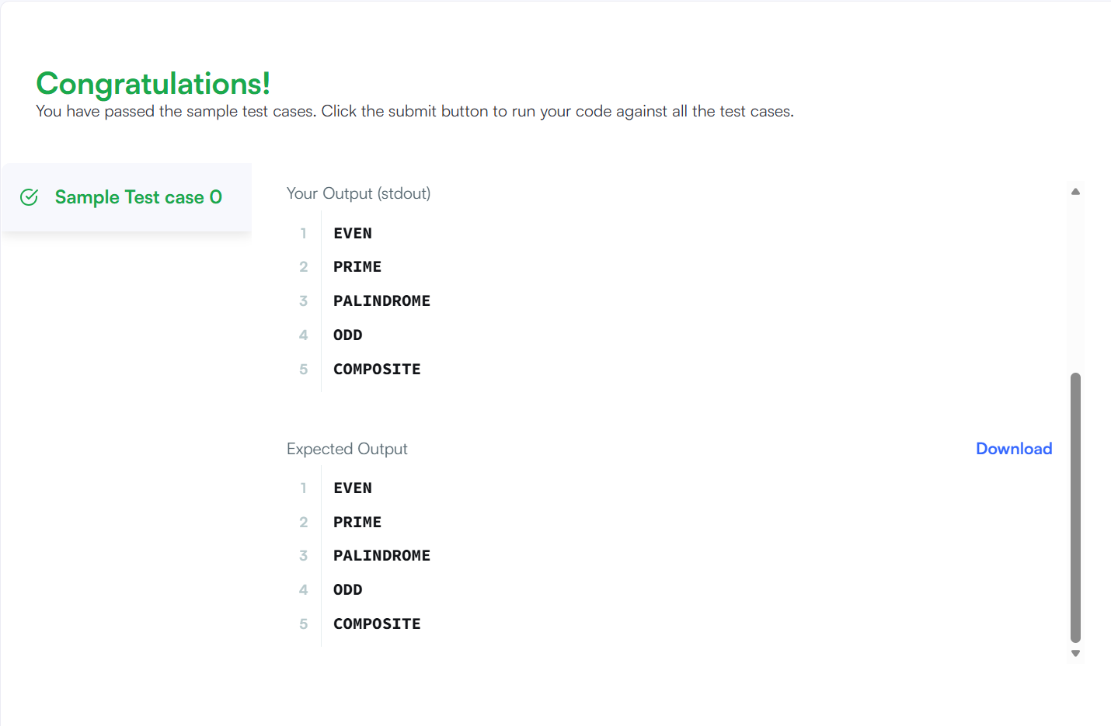
Result :
It correctly used lambda expressions and a functional interface to determine whether the given numbers are odd or even, prime or composite, and palindrome or not, and displayed the appropriate output for each test case.

MIN – MAX PROBLEM :
PROGRAM :
import java.util.*;
class Result {
public static void miniMaxSum(List<Integer> arr) {
int min = arr.get(0);
int max = arr.get(0);
long sum = 0;
for (int i = 0; i < arr.size(); i++) {
int val = arr.get(i);
sum += val;
if (val < min) min = val;
if (val > max) max = val;
}
long minSum = sum - max;
long maxSum = sum - min;
System.out.println(minSum + " " + maxSum);
}
}
public class Solution {
public static void main(String[] args) {
List<Integer> arr = Arrays.asList(1, 2, 3, 4, 5);
Result.miniMaxSum(arr);
}
}

IS-PALINDROME PROBLEM :
PROGRM :
public class practice{
public static boolean ispalindrome(String name){
int n = name.length();
for(int i=0;i<n/2;i++){
if(name.charAt(i) != name.charAt(n-i-1)){
return false;
}
}
return true;
}
public static void main(String[] args) {
String name = "noop";
System.out.println(ispalindrome(name));
}
}
OUTPUT :
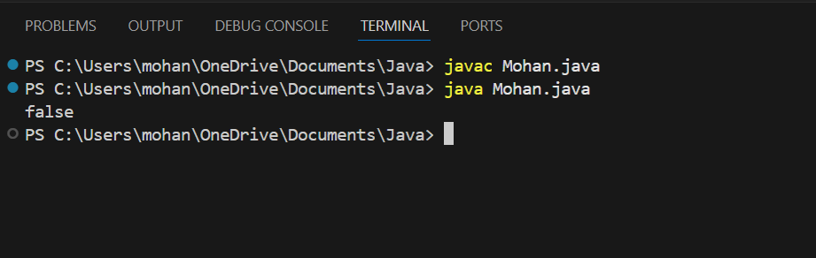

ALL DIGIT COUNT :
PROGRAM :
class UserMainCode {
public static int digitCount(int num) {

int count = 0;

while (num != 0) {
count++;
num = num / 10;
}

return count;
}
}

OUTPUT :
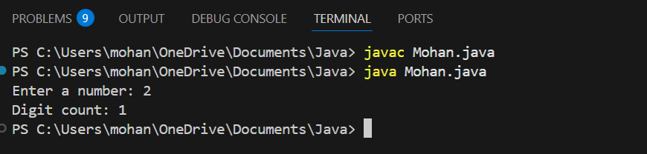

JAVA DATE AND TIME
PROGRAM
public static String findDay(int month, int day, int year) {

Calendar cal = Calendar.getInstance();
cal.set(year, month - 1, day);

int dayOfWeek = cal.get(Calendar.DAY_OF_WEEK);

String[] days = {
"SUNDAY",
"MONDAY",
"TUESDAY",
"WEDNESDAY",
"THURSDAY",
"FRIDAY",
"SATURDAY"
};

return days[dayOfWeek - 1];
}

}

OUTPU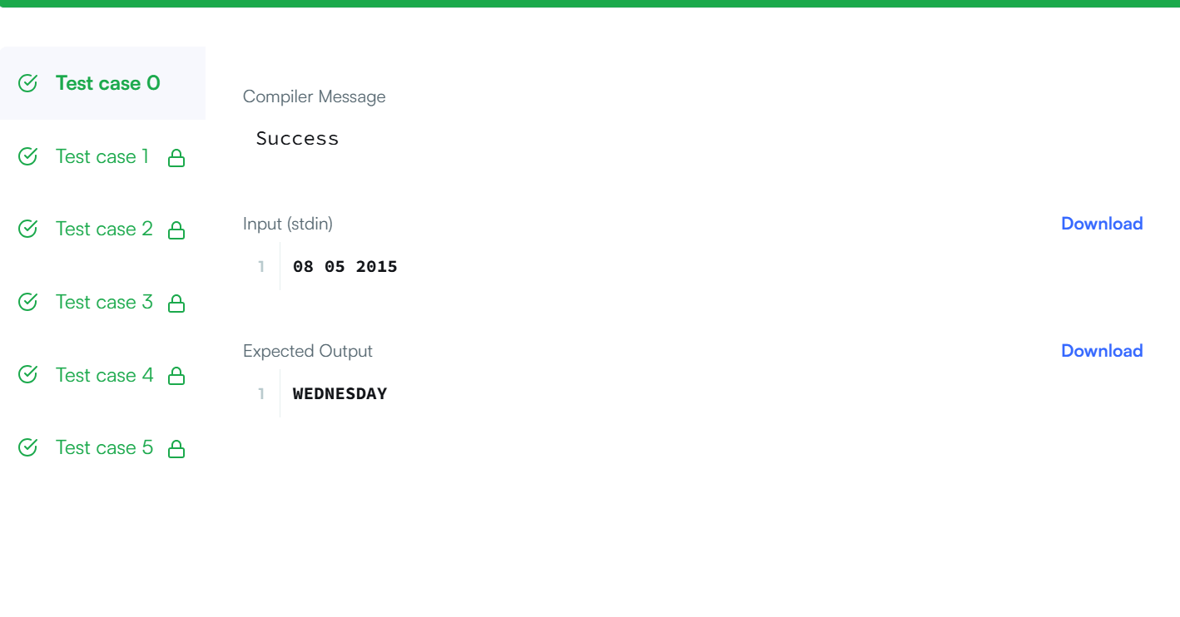

HILL PATTERN :
PROGRAM :
public static int hillWeight(int N, int headWeight, int increment) {
int total = 0;

for (int i = 1; i <= N; i++) {
int weightPerStar = headWeight + (i - 1) * increment;
total += i * weightPerStar;
}

return total;
}

OUTPUT :
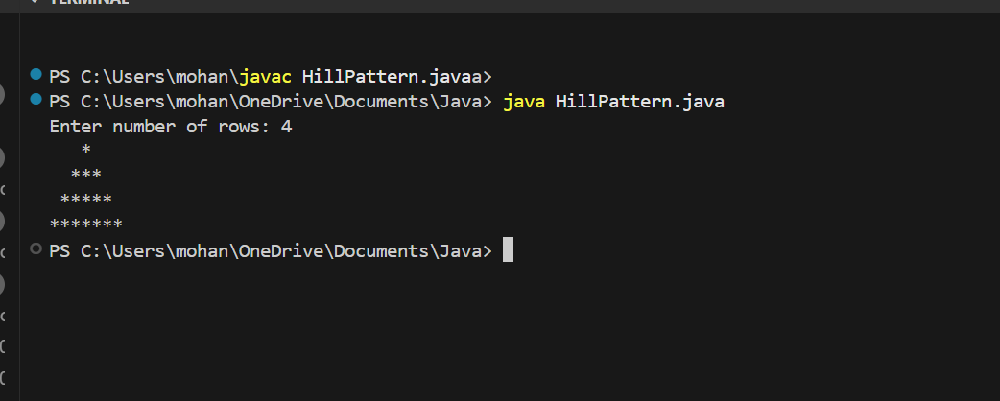

SUM OF SUMS OF DIGIT
PROGRAM :
public class practice{
public static int sumofdigit(int input){
String num = String.valueOf(input);
int total = 0;

for(int i = 0;i<num.length();i++){
int currentsum = 0;
for(int j =i;j<num.length();j++){
currentsum += num.charAt(i) - '0';
}
total += currentsum;
}
return total;
}
public static void main(String[] args){
System.out.println(sumofdigit(3456));
}
}
OUTPUT :
